***Technical Report*** -Project_1:

Robotic Arm

Group Member: Chuyun Hu, Te Li, Xiaolan Li

February 09, 2021

**1.Introduction**

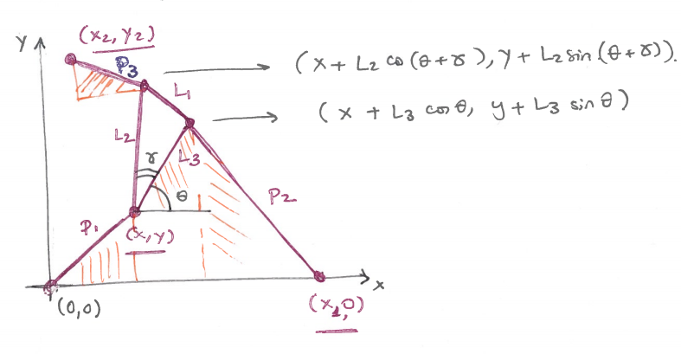 (Figure.1)

In this project, we will explore the Rotation Angle θ and Fixed Point Position (x, y) of the robotic arm consists of three variable length struts P1,P2,P3 and three fixed length struts L1,L2,L3 as shown in Figure.1.

Given target endpoints (x1,0) and (x2,y2), θ and (x,y) are solved by adjusting the stretching length of P1,P2,P3. Thus, we will apply the Methodology combined with computer Experiments to solve the research questions as shown in Figure.2.

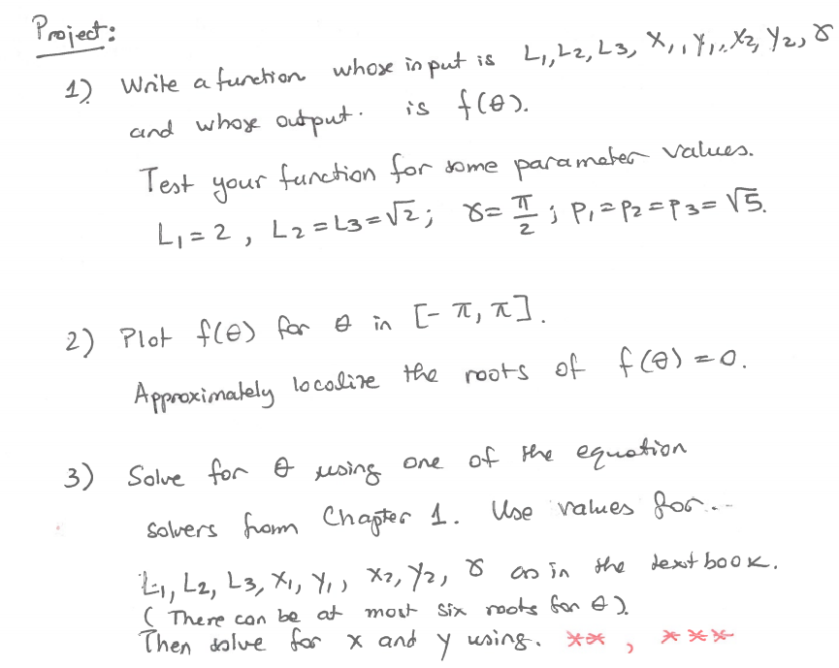 (Figure.2)

**2. Methodology**

For the robotic arm with fixed parameter , , and ɑ, if parameter ,, , , , is given, we can use the relationship between them to build a system of equation and solve it to get the value of variable x, y, θ.

First we build the system of equations:

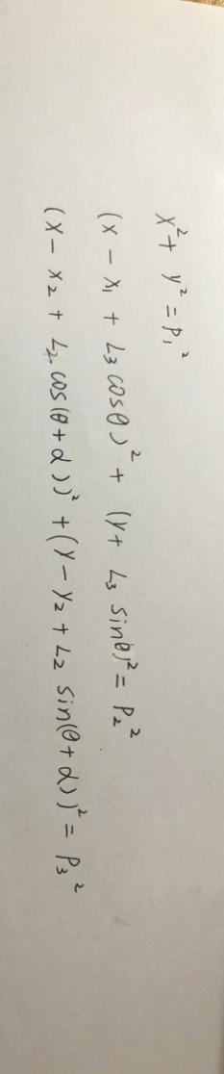 (1)

To solve it, we simplify it to

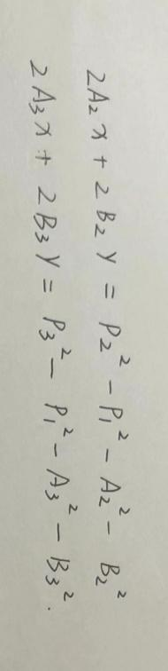(2)

among them

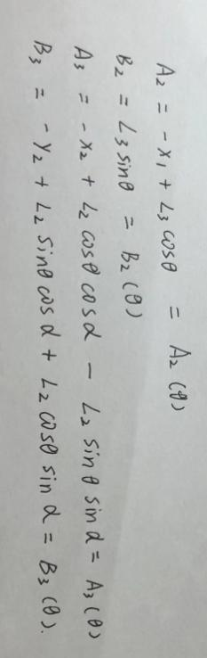

Then, we use cramer’s rule to solve the system of equations (2),

verify



so the system of equations (2) has unique solution:

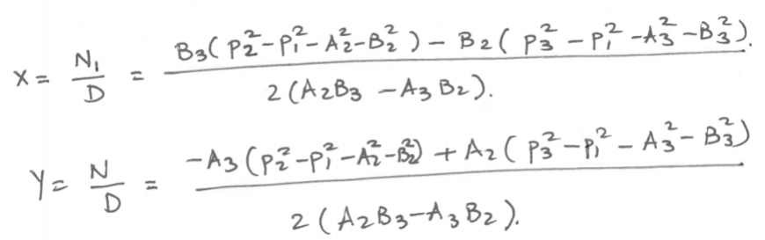(3)

Substitute the system of equations (3) into the first equation in the system of equations (1):

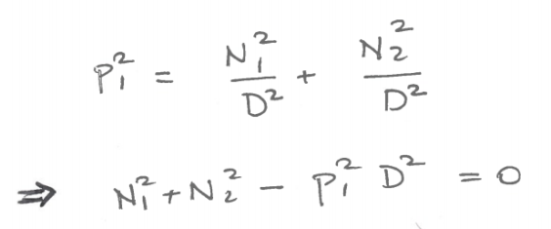

After solve the equation, we can get the value of θ, substitute θ to system (3), we can get the value of x and y.

so, now we turn the problem of solving system (1) to solve equation

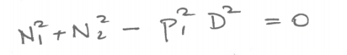(4)

To solve the equation (4), we let

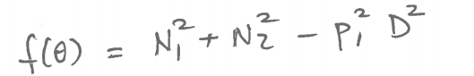

and use bisection method in Python to find root of f(θ).

**3. Computer Experiments/Simulations and Results**

use bisection method to solve equation

1. define function f(Theta) use condition in problem (1)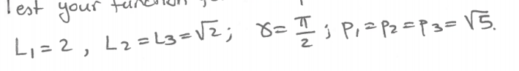x1=4, x2=1, y2=5

and test it:

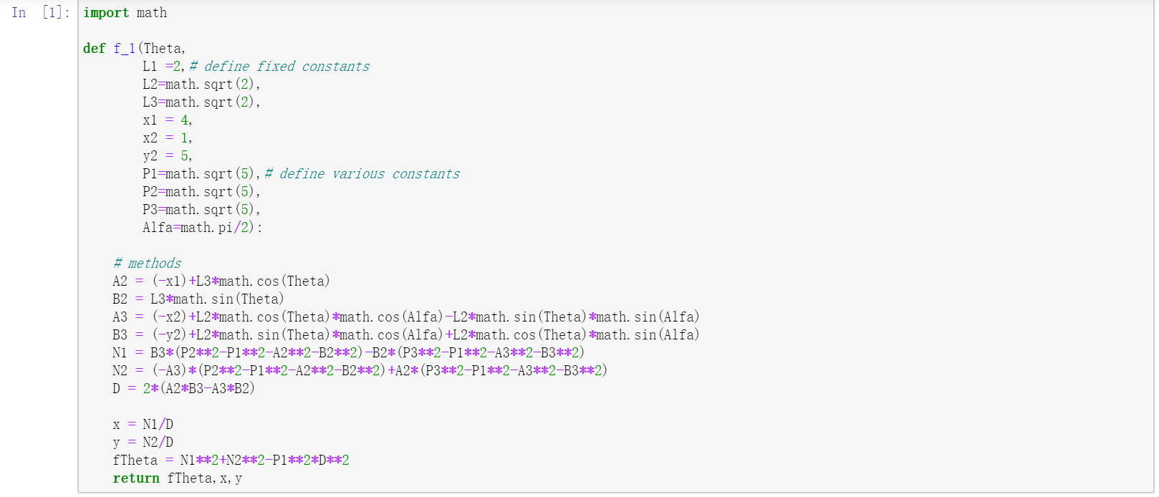

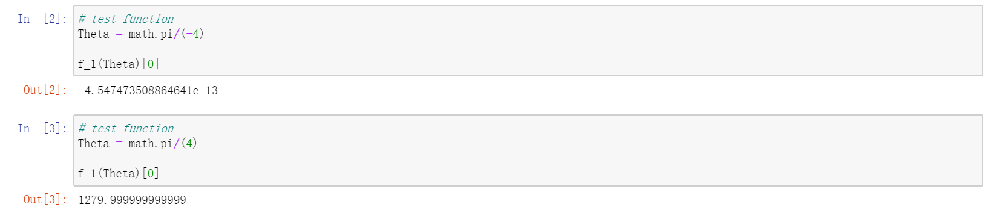

(problem 1)

1. plot the function f(Theta) in order to observe the approximate range of roots

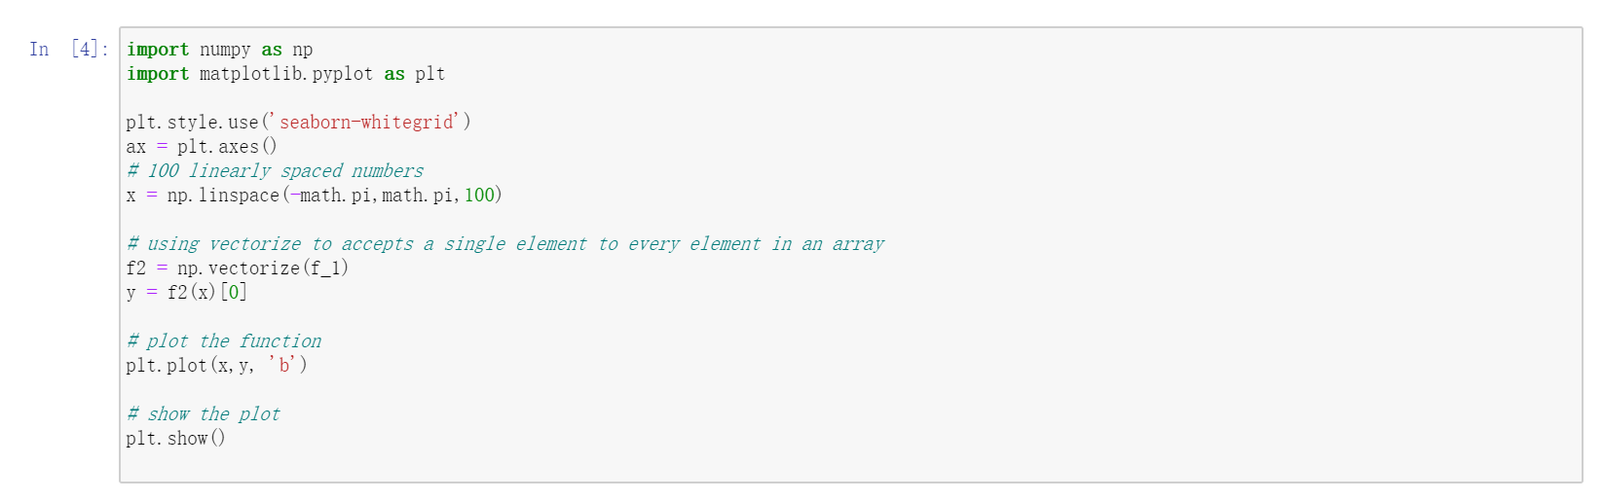

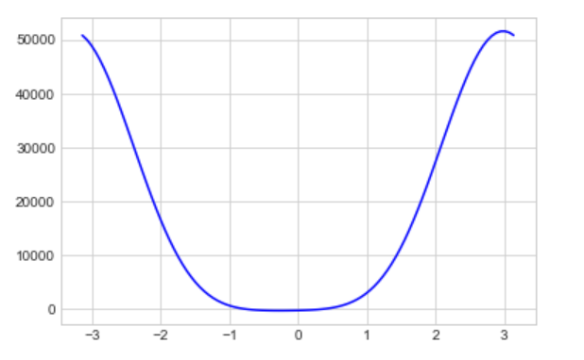

we find the approximate range of roots is [-1.5,1], so we enlarge the image of the function in range [-1.5,1]:

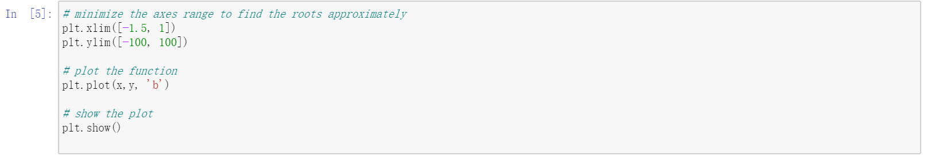

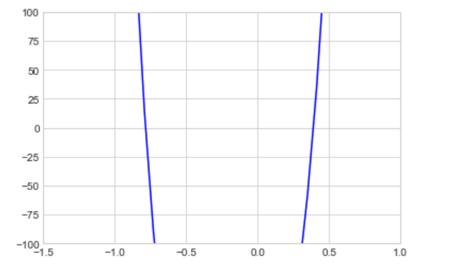

We observe the image and find the roots of f(θ) approximately located at -0.7 and 0.4(problem 2)

1. use bisection method to find roots

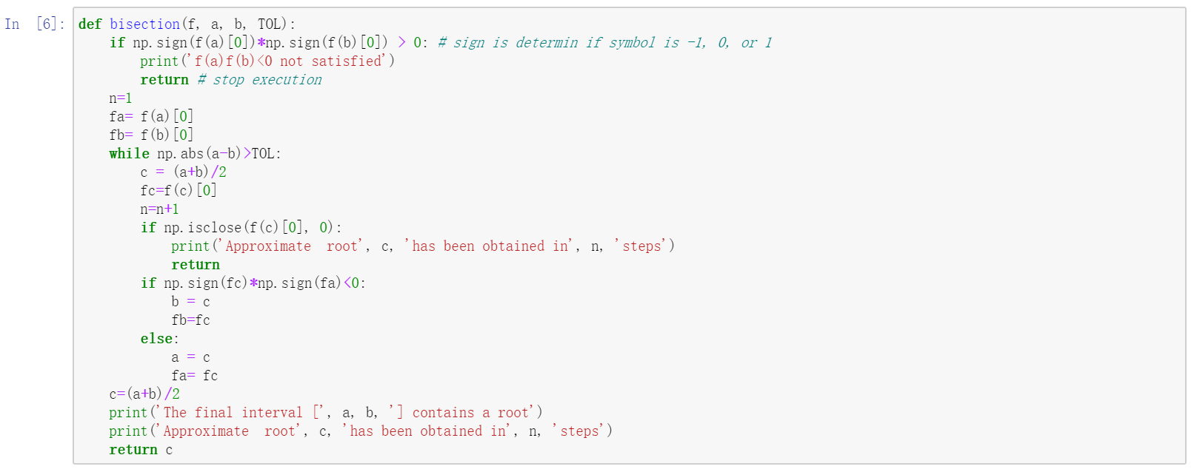

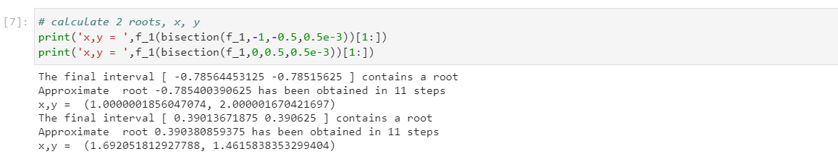

Root1: θ= -0.79 x=1 y=2

Root 2: θ = 0.39 x=y=1.46(problem 3)

1. expansion about 4 roots and 6 roots:

4 roots situation: let x1=5, x2=0, y2 = 6, L1 = 3, L2 =3*sqrt(2), L3=3, Alfa = pi/4, P1=5, P2=5, P3 = 3 (values are given by textbook)

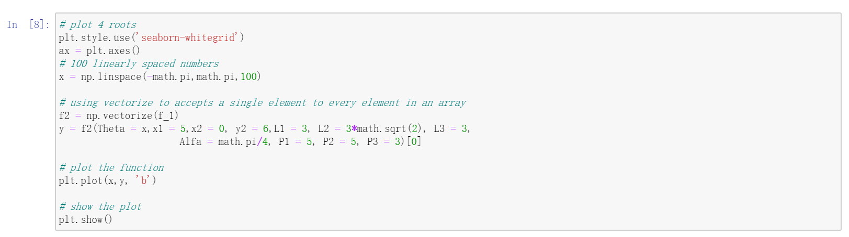

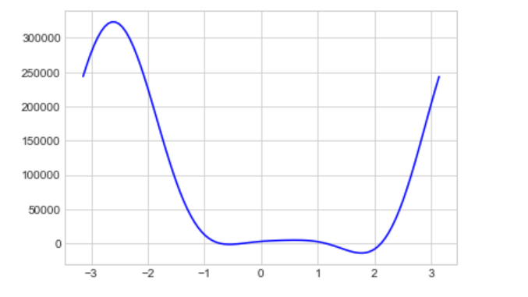

we find the approximate range of roots is [-1,3], so we enlarge the image of the function in range [-1,3]:

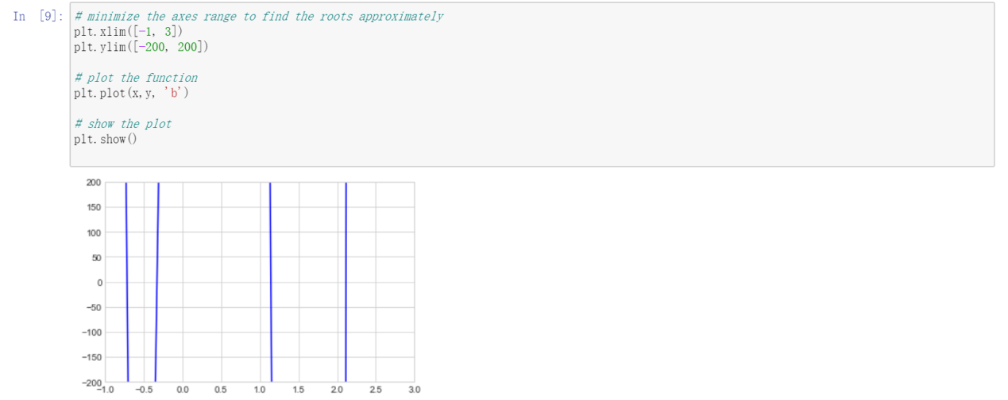

The roots approximately in range [-1, -0.5], [-0.5, 0],[1, 1.5],[2, 2.5]

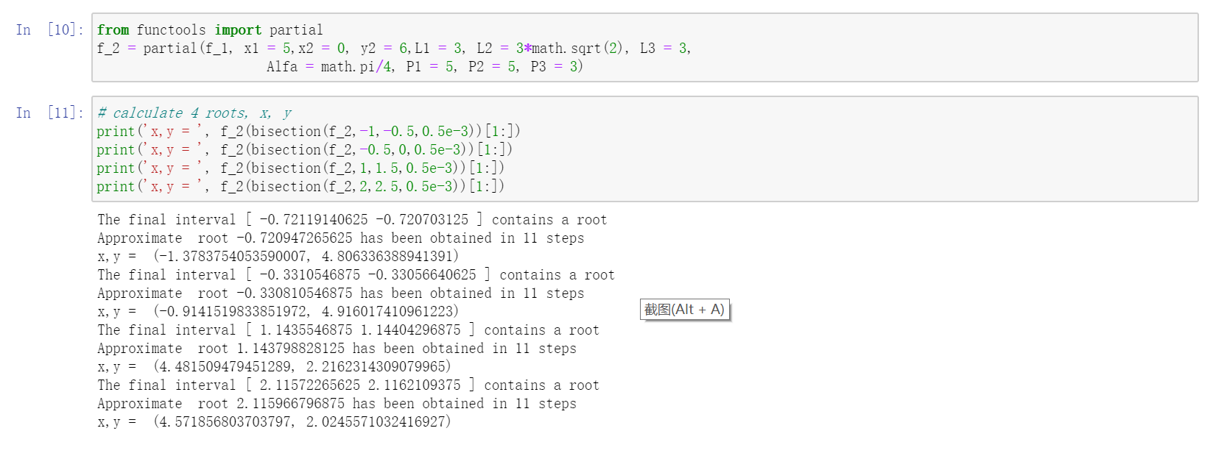

Root1: θ= -0.72 x= -1.39 y= 4.81

Root2: θ= -0.33 x= -0.91 y= 4.92

Root3: θ= 1.14 x= 4.48 y= 2.22

Root4: θ= 2.12 x= 4.57 y= 2.02

6 roots situation: let x1=5, x2=0, y2 = 6, L1 = 3, L2 =3*sqrt(2), L3=3, Alfa = pi/4, P1=5, P2=7, P3 = 3 (change the P2 value to 7)

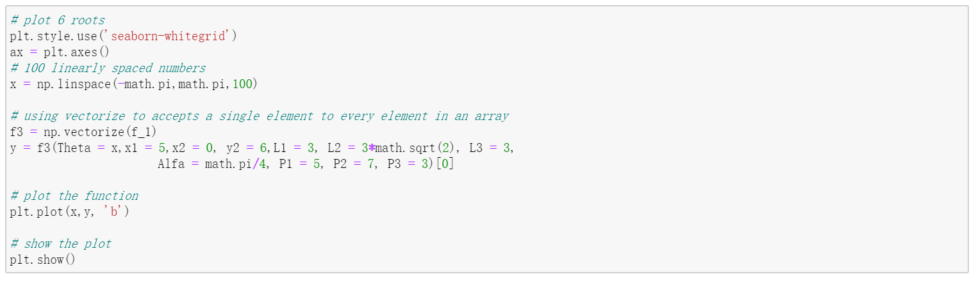

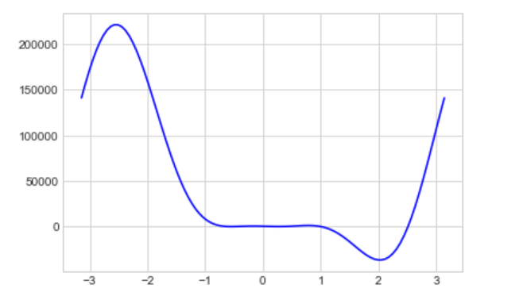

we find the approximate range of roots is [-1,3], so we enlarge the image of the function in range [-1,3]:

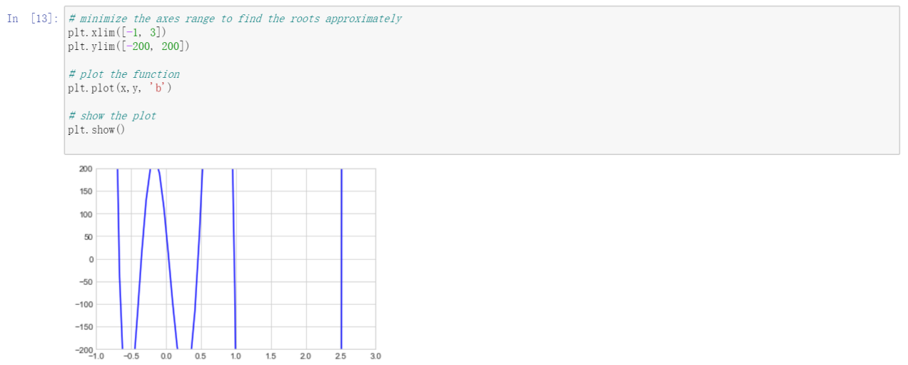

The roots approximately in range [-1, -0.5], [-0.5, 0],[[0, 0.25],[0.25, 0.5],[0.5, 1],[2, 3]

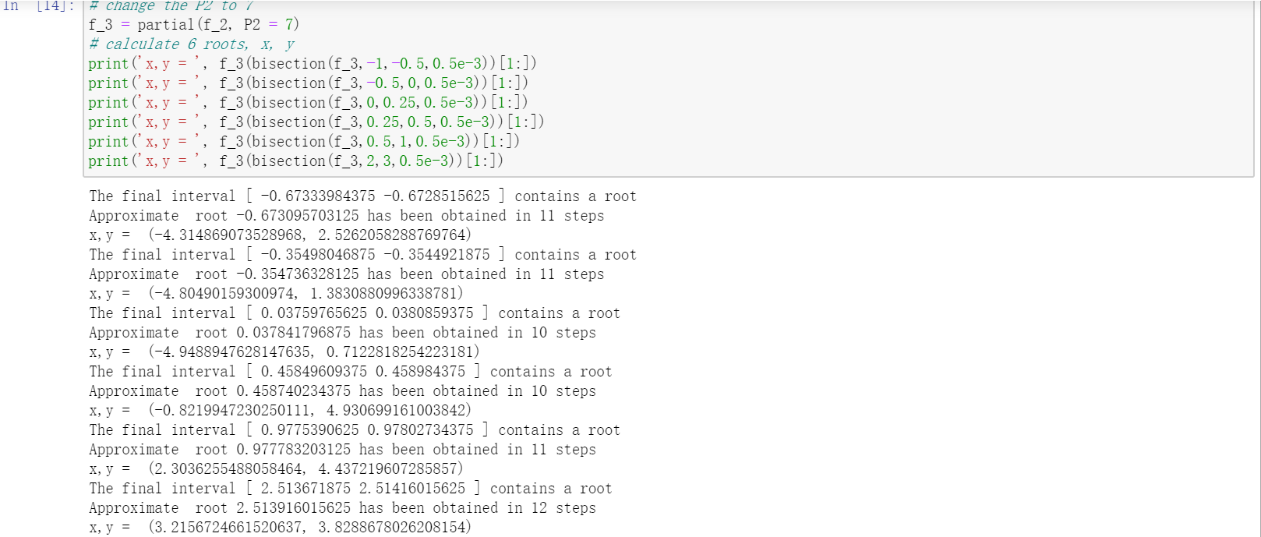

Root1: θ= -0.67 x= -4.31 y= 2.53 Root2: θ= -0.35 x= -4.80 y= 1.38

Root3: θ= 0.04 x= -4.95 y= 0.71 Root4: θ= 0.46 x= -0.82 y= 4.93

Root5: θ= 0.98 x= 2.30 y= 4.44 Root6: θ= 2.51 x= 3.22 y= 3.83

**5.Conclusions**

So far, we used Bisection methods to input different parameters to the robot arm to get different roots of θ, x, y in multiple P value cases. Under different root conditions, the robotic arm can rotate flexibly. We find that when there are multiple roots to choose from, we can choose the optimal root with fewer iterations step.

1. **References cited.**

<https://en.wikipedia.org/wiki/Cramer%27s_rule>

<https://en.wikipedia.org/wiki/Stewart_platform>

<https://en.wikipedia.org/wiki/Parallel_manipulator>